**Experiment No.6**

**Aim:**  Edit/compile/run a program to display the Floyd Triangle.

**Program A:**

n=int(input("Enter the total Number of Rows:-"))  
count=1  
for i in range(1,n+1):  
 for j in range(1,i+1):  
 print(count,end= ' ')  
 count=count+1  
 print()

**Output:**

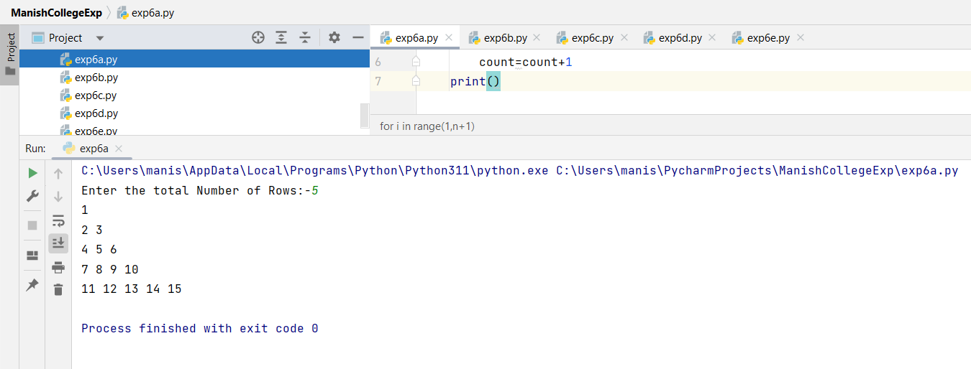

**Program B:**

n=int(input("Enter the total Number of Rows:-"))  
count=1  
i=1  
while(i<=n):  
 j=1  
 while(j<=i):  
 print(count,end=' ')  
 count=count+1  
 j=j+1  
 i=i+1  
 print()

**Output:**

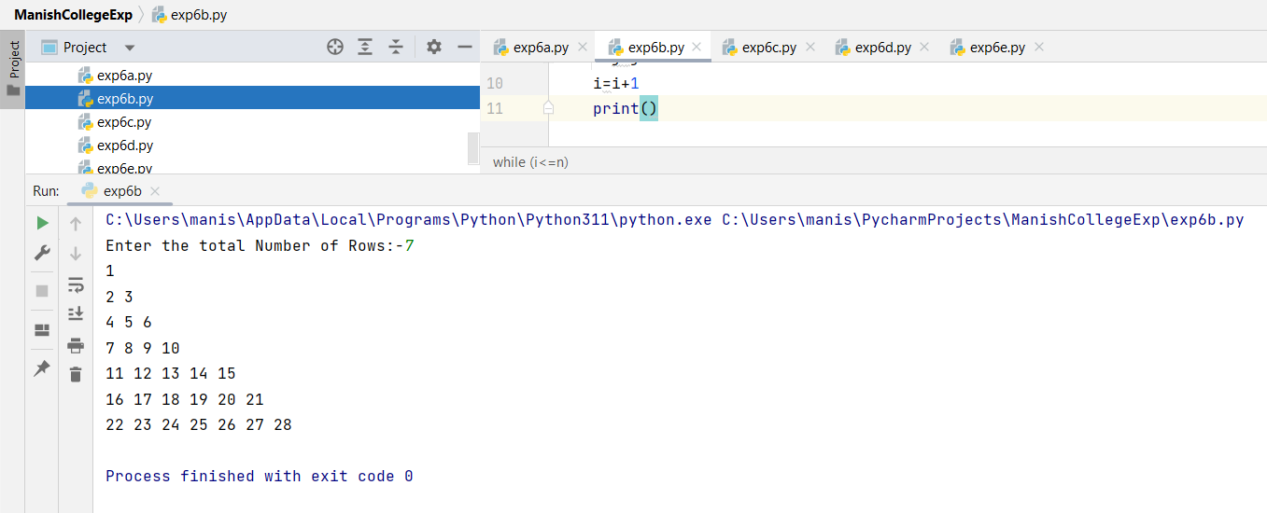

**Program C:**

print("Enter the Number of Rows:",end="")  
row=int(input())  
num=1  
for i in range(row):  
 for j in range(i+1):  
 print(num,end=' ')  
 num=num+1  
 print()

**Output:**

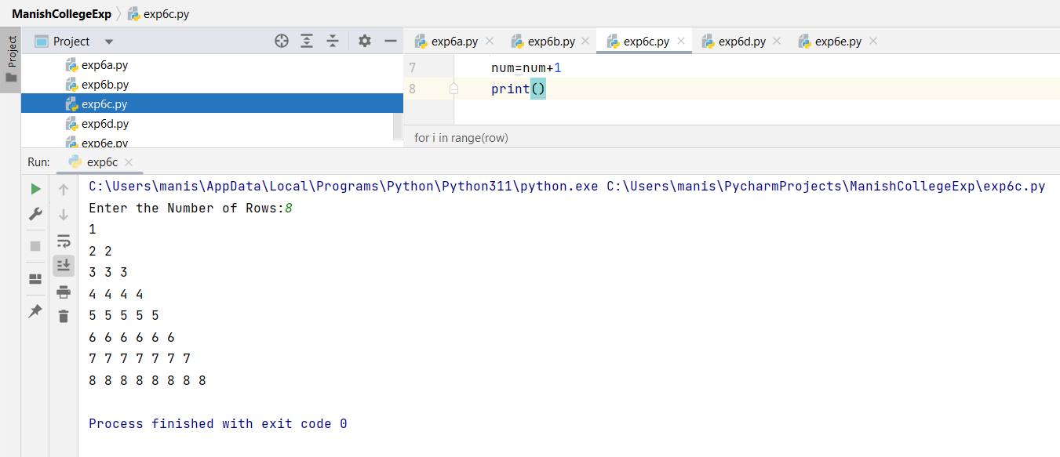

**Program D:**

print("Enter the Number of Rows:",end="")  
row=int(input())  
num=1  
i=0  
while i<row:  
 j=0  
 while j<i+1:  
 print(num,end=' ')  
 num=num+1  
 j=j+1  
 print()  
 i=i+1

**Output:**

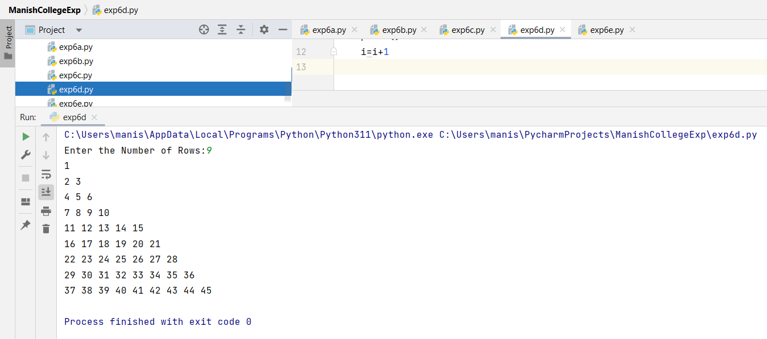

**Program E:**

rows = int(input("Enter the number of rows: "))  
*# Pattern 1*print("\nPattern 1:")  
number = 1  
for i in range(1, rows+1):  
 for j in range(1, i+1):  
 print(number, end=" ")  
 number += 1  
 print()  
number -= 1  
for i in range(rows-1, 0, -1):  
 for j in range(i, 0, -1):  
 print(number, end=" ")  
 number -= 1  
 print()  
  
*#Pattern 2*print("\nPattern 2:")  
num = int(input("Enter the number of rows: "))  
for i in range(num, 0, -1):  
  
 for j in range(0, num - i):  
 print(end=" ")  
  
 for j in range(0, i):  
 print("*", end=" ")  
  
 print()

**Output:**

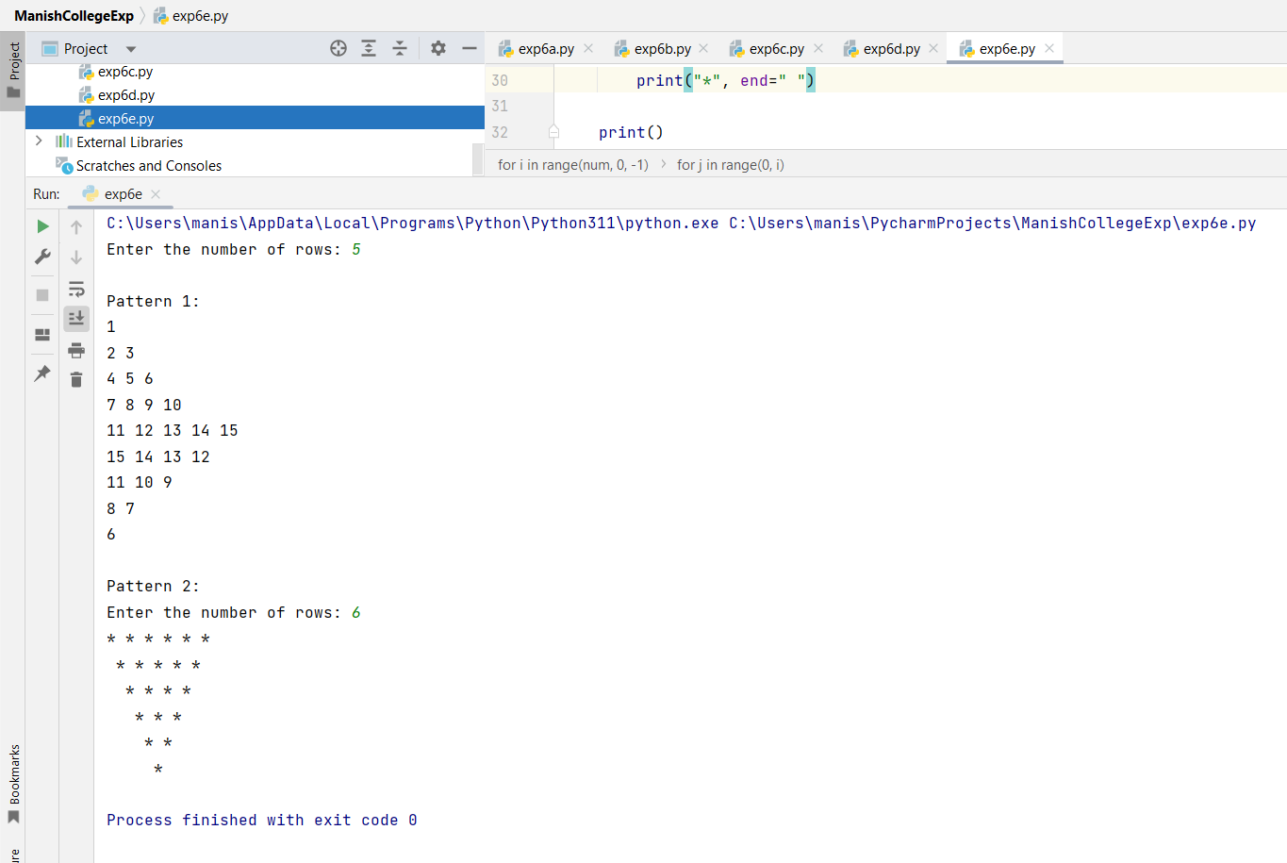

**Program F:**

row = int(input("Enter the number of rows: "))  
number = 1  
for i in range(1, row+1):  
 for j in range(1, i+1):  
 print(number, end=" ")  
 number += 1  
 print()  
number -= 1  
for i in range(row-1, 0, -1):  
 for j in range(i, 0, -1):  
 print(number, end=" ")  
 number -= 1  
 print()  
number = 1  
for i in range(1, row+1):  
 for j in range(1, i+1):  
 print(number, end=" ")  
 number += 1  
 print()

**Output:**

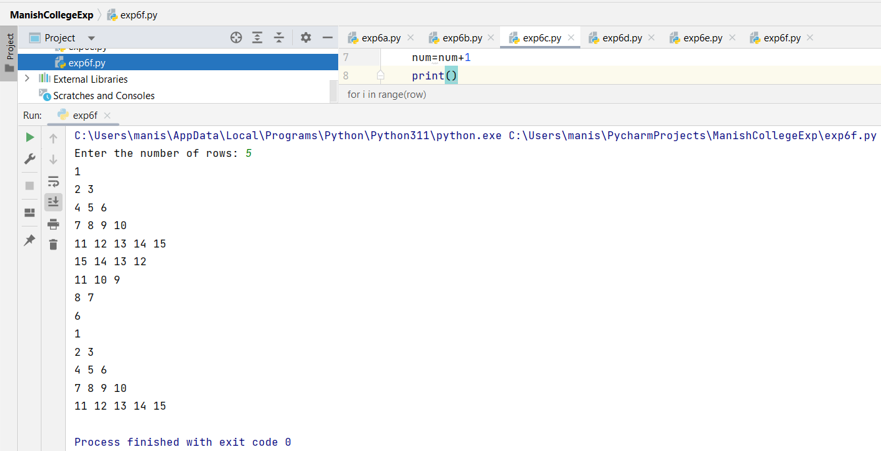

|  |  |  |  |
| --- | --- | --- | --- |
| **Practical Performance**  **(4)** | **Writeup & Oral**  **(4)** | **Attendance**  **(2)** | **Total**  **(10)** |
|  |  |  |  |